📘 Project:
Intelligent Library Management System using Heuristic Search Algorithms (A*, Hill Climbing, Graph Search)

🧩 1. Object Diagram

🧠 Purpose
An Object Diagram shows instances of classes at a particular moment — it is a snapshot of the system’s state at runtime.
It’s derived from your Class Diagram, but instead of classes, we show objects (e.g., specific books or members).

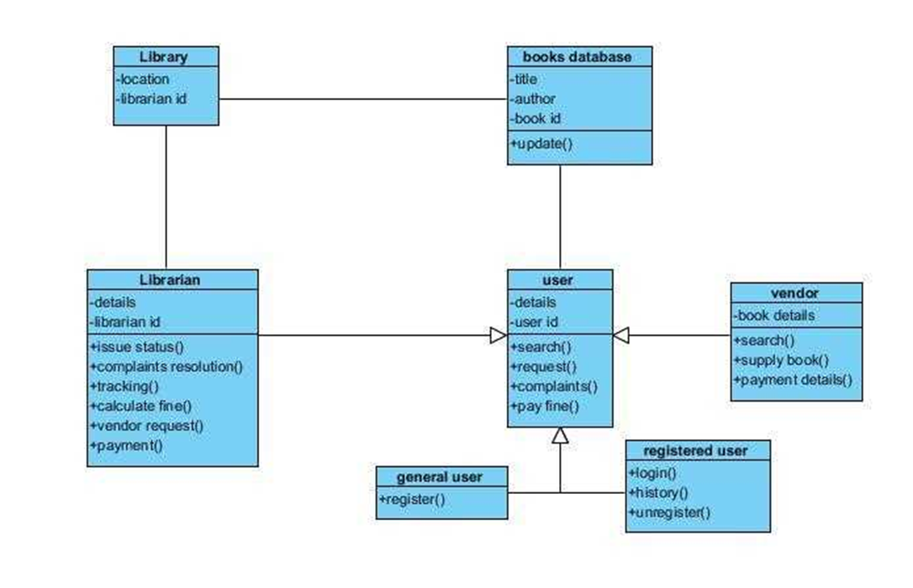

🧱 2. Software Architecture Diagram

🏗️ Purpose
The Software Architecture Diagram describes the overall structure of the LMS — how modules, databases, and algorithms are organized and interact.
